Final Project
Churn Prevention System

Table of Contents
1. Project Objective 2
2. Dataset 2
3. Problem Formulation 3
4. Common Pipeline 3
5. System Diagram Requirement 6
6. Engineering Requirements 7
7. Expected Outcome 7

1. Project Objective
The goal of this project is to build a complete end-to-end Churn Prevention System that combines:
- Churn Prediction: Identify customers who are likely to stop purchasing
- Recommendation System: Suggest personalized products to retain those customers
You will implement a full pipeline from raw transactional data → modeling → serving → evaluation, simulating a real-world production ML system.
The system should include:
- Data preprocessing & feature engineering
- Churn prediction model
- User–item representation learning
- Retrieval + ranking recommendation system
- (Optional) LLM-based reranker
- REST API serving
- Offline evaluation & business analysis
The final system must simulate a production-ready ML system, including:
- CI/CD pipeline (optional)
- A complete system architecture diagram (Draw.io / Excalidraw)
- Clear separation between offline training and online inference
Example of required Churn Diagram:
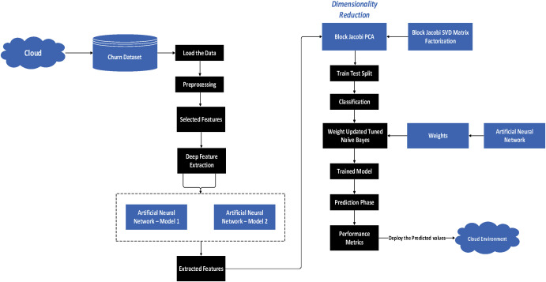
Source: https://www.sciencedirect.com/science/article/abs/pii/S0952197623011995

Example of required Recommendation Diagram:
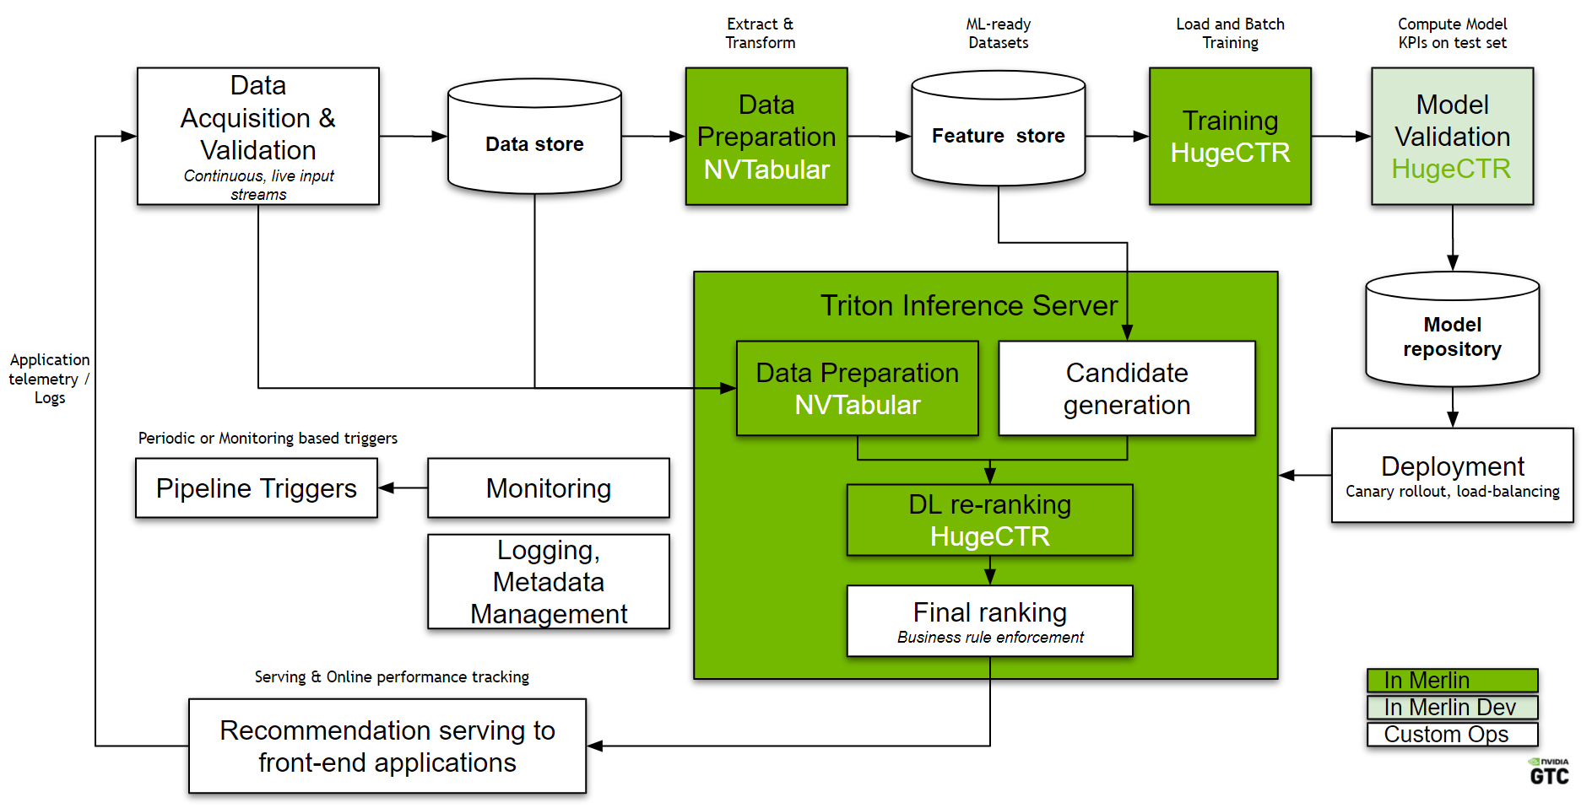
Source: https://developer.nvidia.com/blog/continuously-improving-recommender-systems-for-competitive-advantage-with-merlin-and-mlops/
Example of required CI/CD deployment:
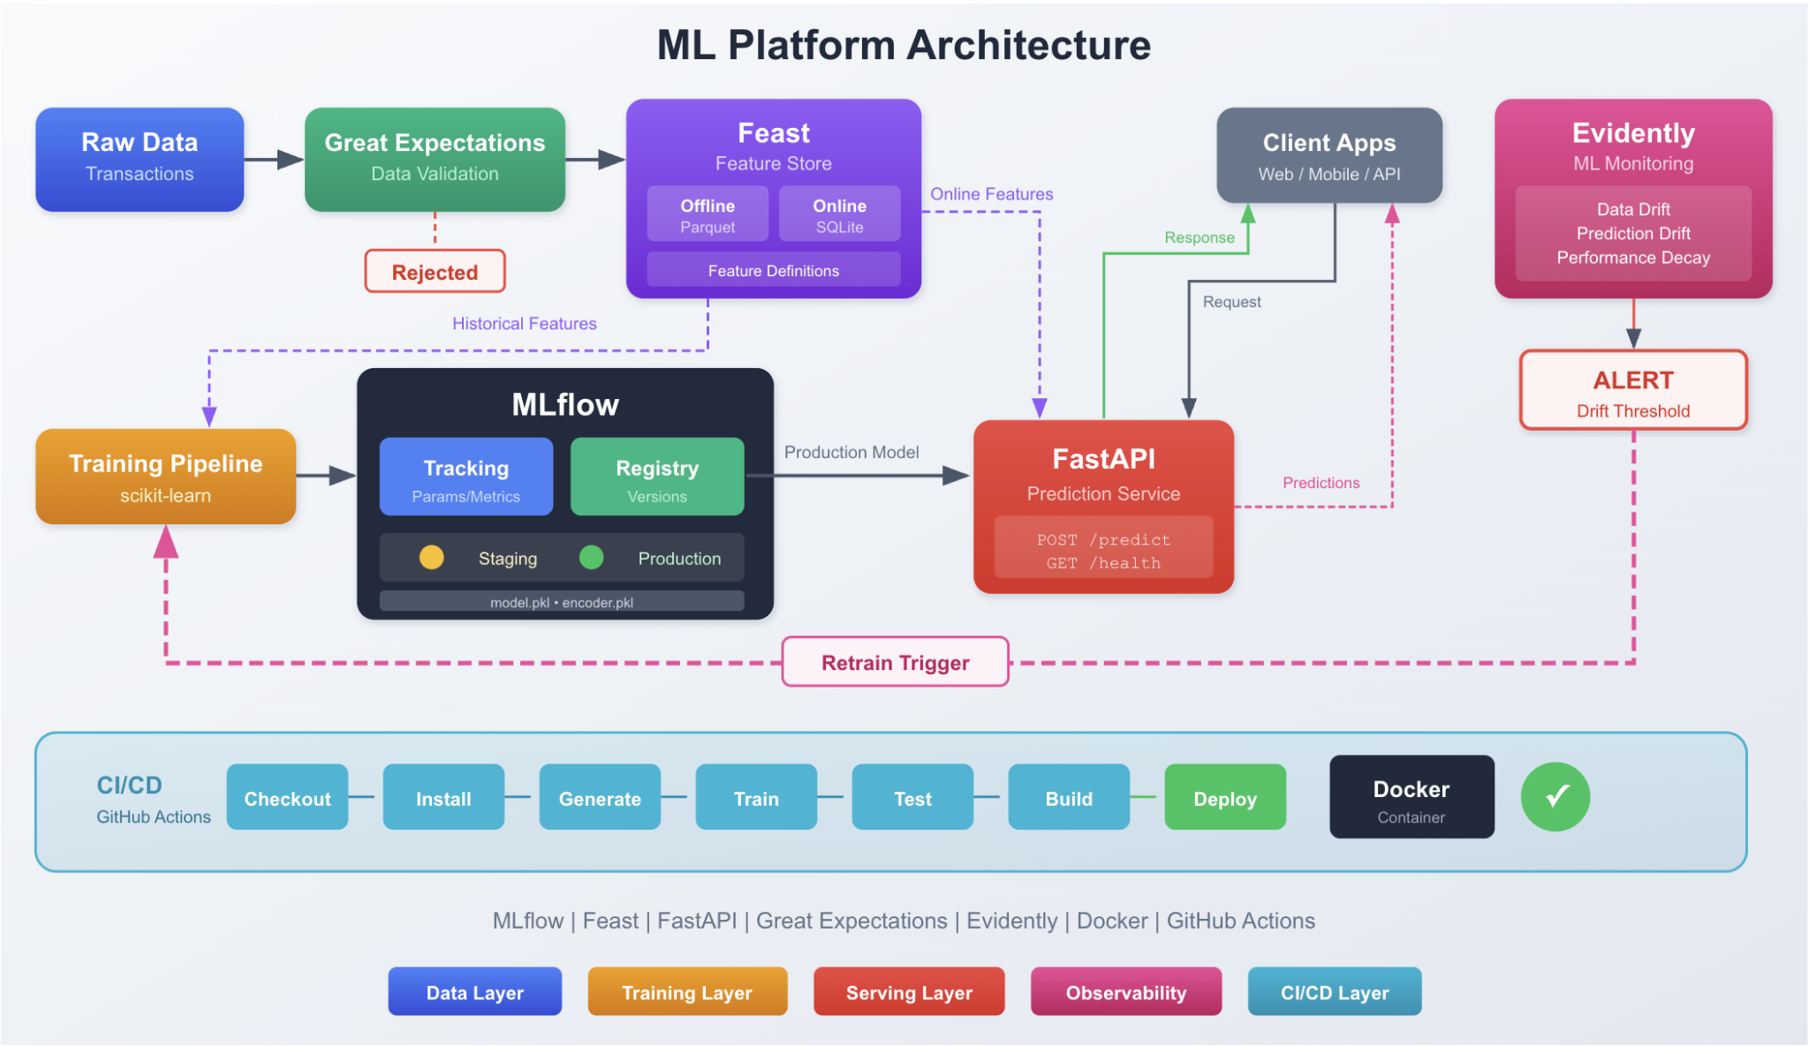
Source: https://www.freecodecamp.org/news/build-end-to-end-ml-platform-locally-from-experiment-tracking-to-cicd/
Note: The expected diagram should be a combination of the 3 diagrams above.

2. Dataset

Dataset Used: Online Retail II Dataset

Download Link: https://www.kaggle.com/datasets/mashlyn/online-retail-ii-uci

Dataset Description
This dataset contains real-world e-commerce transaction data from a UK-based online retailer.
Main fields:
- CustomerID: unique customer identifier
- InvoiceDate: timestamp of transaction
- StockCode: product ID
- Quantity: number of items purchased
- Price: unit price

3. Problem Formulation

3.1 Churn Definition
Since the dataset does not include churn labels, you must define churn based on behavior.
- A customer is considered churned if they have no purchase within the next 90 days after their last transaction.

3.2 Label Construction
For each customer:
- Sort transactions by time
- Identify last purchase date in training window
- Check if the customer returns within next N days (e.g., 90 days)
- If NO → churn = 1
- If YES → churn = 0

3.3 Feature Engineering (for Churn Model)
- Recency: Days since last purchase
- Frequency: Number of transactions
- Monetary: Total spending
- Behavioral features:
  - Avg basket size
  - Purchase interval
  - Product diversity

4. Common Pipeline

4.1 Data Pipeline
- Clean transactional data
- Remove invalid records (returns, null CustomerID, etc.)
- Generate:
  - Churn dataset (user-level)
  - Interaction dataset (user–item level)
- Perform time-based train/validation/test split

4.2 Churn Prediction Model
Train a model to predict churn probability.
Supported models:
- Churn Classification
- BG-NBD
- Survival Analysis
Output:
- Churn probability score per user
- Or p-alive, associated with time to churn

4.3 Retrieval Model (Recommendation Candidate Generation)
Build a model to learn user and item embeddings.
Supported approaches:
- ALS
- Item2Vec
- Two-Tower model
- Graph-based recommendation
Output:
- User embedding
- Item embedding
- Top-N candidate items

4.4 Approximate Nearest Neighbor Search (FAISS)
- Build FAISS index from item embeddings
- Retrieve Top-N items for each user

4.5 Ranking Model (Churn-Aware Recommendation)
Train a ranking model to prioritize the best products for retention.
Input features:
- User embedding
- Item embedding
- Churn probability
- Interaction features
Supported models (one of these models):
- BPR
- NeuMF
- Wide & Deep / DeepFM
- Sequential models
Output:
- Ranked Top-K recommendations

4.6 Optional: LLM-based Reranker
Use an LLM to refine recommendations.
Input:
- User behavior summary
- Product metadata
Output:
- Semantically improved ranking

4.7 Decision Layer (Retention Strategy)
Combine:
- Churn probability
- Recommended products
To produce:
- Final retention action (e.g., product suggestion, discount targeting)

4.8 API Serving
Build a REST API:
- input user → churn prediction → retrieval → ranking → output Top-K products
Requirements:
- At least one inference endpoint
- Use FastAPI
- Dockerize the system

4.9 Evaluation Report

Churn Model Metrics
- AUC-ROC
- Precision / Recall / F1

Recommendation Metrics
- Recall@K
- NDCG@K

Business Evaluation
- Performance on high-churn segment
- Recommendation impact on retention

Ablation Study
Compare:
- Churn only
- Churn + Retrieval
- Churn + Retrieval + Ranking
  - LLM (optional)

5. System Diagram Requirement
You must provide a system architecture diagram including:

Offline Pipeline
- Data preprocessing
- Feature engineering
- Churn model training
- Embedding training
- FAISS indexing

Online Pipeline
- API request
- Churn scoring
- Candidate retrieval
- Ranking
- Response generation
Clearly separate:
- Training phase
- Inference phase

6. Engineering Requirements

Suggested Project Structure
- data/
- features/
- models/
  - churn/
  - retrieval/
  - ranking/
- faiss/
- api/
- evaluation/

Technical Requirements
- PyTorch for modeling
- FAISS for ANN search
- FastAPI for serving
- Docker for deployment

Code Quality
- Reproducible pipeline
- Well-documented code
- Publish on GitHub

7. Expected Outcome
By completing this project, you will:
- Understand how to combine churn prediction + recommendation systems
- Learn how to define labels from raw behavioral data
- Build a production-style ML system
- Gain hands-on experience with end-to-end system design

